**PRESS MODEL PL 120s 3500x1300 mm PS VBO**

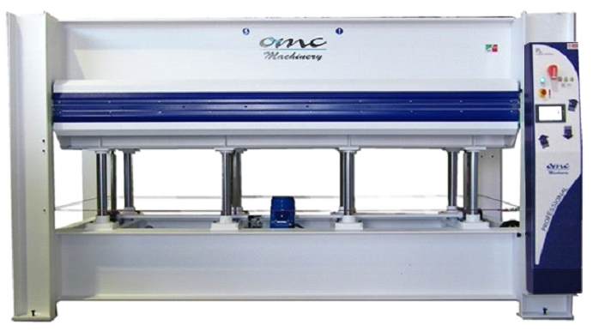

The pictures are for reference only

Dear customer,

Thank you for enquiring with OMC Machinery.

OMC Machinery is an artisan family run business that since 1983 has designed, manufactured and installed top quality and highly reliable pressing machines.

We always provide our customers with technical assistance throughout the entire life cycle of the machinery, from the designing process to the after sales technical support, to ensure the maximum efficiency.

**PRESS MODEL PL 120s 3500x1300 mm PS VBO**

|  |  |
| --- | --- |
| CARATTERISTICHE TECNICHE | |
| Platens dimensions | 3500x1300 mm |
| Stroke | 400 mm |
| Type of stroke | Upstroke design (from bottom to top) |
| Type of platen | Assembled platens with coil and aluminum surface |
| Total thrust | 120 ton on 80% of the surface |
| Pressing Cylinders | N° 8 cylinders ø 70 mm |
| Exclusion of cylinders | **N. 2 cylinders can be excluded** |
| Sensors to check parallel stroke | **included** |
| Specific Pressure | 2,93 kg/cm2 on 80% of the surface  2,35 kg/cm2 on 100% of the surface |
| Loading and Unloading Side | 3500 mm side |
| Type of Heating system | Oil boiler 27 kW |
| Heating system specifications | Automatic with timer |
| Opening | **Digital “touch screen” panel + PLC** |
| Control Board | 400V, 50Hz, 3ph |
| Power supply | Safety cable all around the press  Red emergency Button  Two Hand control |
| Security device | CE norms |

**Press Structure**

The press structure is made of S275JR steel beams assembled and welded together.

The structure of both the fixed and movable platen is made of fe 430 beams assembled and welded together. The press is equipped with rack and pinion guide system to ensure a perfectly parallel movement during the closing/opening of the platens.

|  |  |  |  |  |  |  |
| --- | --- | --- | --- | --- | --- | --- |
| **Heating platens**  **Assembled platens with coil and aluminum surface**   |  |  | | --- | --- | | Maximum temperature of the heating fluid **120°C**  Maximum specific  working thrust **3÷5 kg/cm²**  Maximum  thrust of heating Fluid: **2 bar**  Our coil platens are completely built in our carpentry workshop. Each coil, before being mounted on the press, is submitted to a strict leak test. | C:\Users\Marilena\Desktop\guida quotazioni\coilass.png | | A **3 mm** calibrated sheet is placed on top of the coil.  The platen is covered with aluminum sheet, that gives the platens an excellent surface finish and optimal heat propagation. | | |  | |   **Hydraulic system**   * the hydraulic system consists of a double stage unit with submerged pump to reduce the noise and lubricate the rotating parts. * quick closing/opening pump (high delivery- low pressure **35 L/min**), pressing pump (low delivery-high pressure **2.4 L/min**). * **3 hp** electric engine * the hydraulic unit is equipped with the following control/safety valves, installed on the tank:   - maximum pressure valve. this valve prevents to have too high pressure in the hydraulic  system in case of electric or electronic control fault  - pressure holding valve (retaining valve)  - low releasing pressure valve (pre-releasing valve). It avoids dangerous ram hits inside  the system  - oil release control magnet |

|  |  |
| --- | --- |
| **Touch screen display – Programmable Logic Controller** | |
| Full colour touch screen 7” display, specifically designed to manage the following parameters:  - temperatures  - pressing time  - daily setting of the heating system  - automatic switching off of the heating system once the set  temperature is reached and automatic recovery of the  temperature  - new system for the automatic setting of the pressure  - option to save historical data/parameters  - diagnostic system |  |

**Safety devices**

* two hand safety buttons for press closing
* Safety rope along the four sides of the press
* Platen stopping device during maintenance operations
* Safety carter for the pinion/rack group
* Safety stickers and warning notices
* Maintenance and user manual
* **The machine is compliant with CE normatives**
* **PRESS MODEL PL 120s 3500x1300 mm PS VBO**