**HOT PRESS MODEL PL 90s 3000x1300 mm PS VBO Logic**

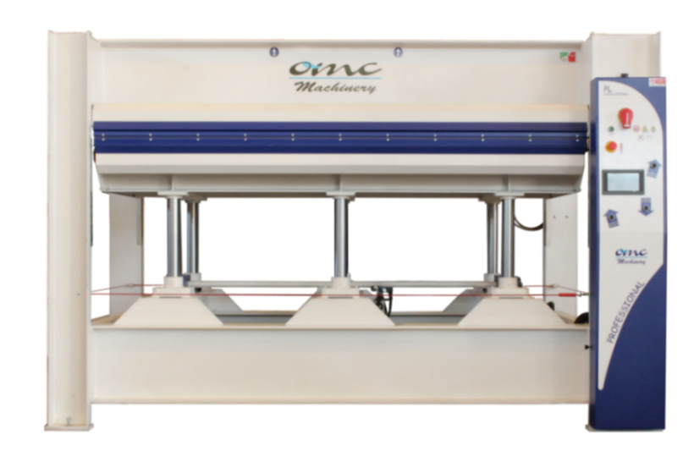

The pictures are for reference only.

Dear customer,

Thank you for enquiring with OMC Machinery.

OMC Machinery is an artisan family run business that since 1983 has designed, manufactured and installed top quality and highly reliable pressing machines.

We always provide our customers with technical assistance throughout the entire life cycle of the machinery, from the designing process to the after sales technical support, to ensure the maximum efficiency.

**HOT PRESS MODEL PL 90s 3000x1300 mm PS VBO Logic**

|  |  |
| --- | --- |
| TECHNICAL CHARACTERISTICS | |
| Platens dimensions | 3000x1300 mm |
| Stroke | 400 mm |
| Type of stroke | Upstroke design (from bottom to top) |
| Type of platen | Assembled platens with coil and aluminum covering |
| Total thrust | 90 ton on 80% of the surface |
| Pressing Cylinders | N° 6 cylinders ø70 mm |
| Specific Pressure | 2.05 kg/cm2 on 100% of the surface  2.56 kg/cm2 on 80% of the surface |
| Loading and Unloading Side | 3000 mm side |
| Sensors to check parallel stroke | **included** |
| Type of Heating system | Oil boiler – maximum temperature = 120°C |
| Heating system specifications | Electric boiler 18 kW |
| Opening | Automatic by timer |
| Control Board | **Touch screen panel “logic control” + PLC** |
| Power supply | 400V, 50Hz, 3ph |
| Security device | Safety rope around the press  Red emergency Button  Two Hand control |
| Normative | CE norms |

**Press Structure**

The press structure is made of fe 430 beams assembled and welded together.

The structure of both the fixed and movable platen is made of fe 430 beams assembled and welded together.

The press is equipped with rack and pinion guide system to ensure a perfectly parallel movement during the closing/opening of the platens.

**Assembled platens with coil and aluminium covering**

|  |  |
| --- | --- |
| Maximum oil Temperature **120°C**  Maximum specific working thrust **3-5 kg/cm²**  Maximum thrust of heating Fluid: **2 bar**  Our assembled platens with coil + aluminum covering are completely built in our metal workshop. Each coil, before being installed in the platen, is submitted to a strict leak test. | C:\Users\Marilena\Desktop\guida quotazioni\coilass.png |
| A **3 mm** calibrated sheet is placed on top of the coil.  The platens are covered with aluminum sheet, that gives the platens an excellent surface finish and optimal heat propagation.  **Hydraulic system**   * the hydraulic system consists of a double stage unit. * quick closing/opening pump (high delivery- low pressure **35 L/min**), pressing pump (low delivery-high pressure **1.6 L/min**). * **2 hp** electric engine * the hydraulic unit is equipped with the following control/safety valves, installed on the tank:   - maximum pressure valve: prevents to have too high pressure in the hydraulic  system in case of electric or electronic control fault  - pressure holding valve (retaining valve)  - low releasing pressure valve (pre-releasing valve). It avoids dangerous ram hits inside  the system  - oil release control magnet | |

|  |  |
| --- | --- |
| **Control panel and Electrical system**  **Touch screen display - Programmable Logic Controller** | |
| Colour full touch screen 7” display specifically designed to set the following:  - temperatures  - pressing time  - daily setting of the heating system  - automatic switching off of the heating system  once the set temperature is reached and  automatic recovery of the temperature  - new system for the automatic setting of the  pressure  - option to save historical data/parameters  - diagnostic system |  |

**Safety systems**

- Timed bimanual control for press closing

- Safety rope on the four sides of the press

- Platen locking device for maintenance

- Protection carter for the pinion/rack units

- Safety stickers and warnings

- Use and maintenance manual

- the press is compliant with CE standards

**HOT PRESS MODEL PL 90s 3000x1300 mm PS VBO Logic**