**HOT PRESS MODEL PL 90s 2500x1300 mm PS VBO**

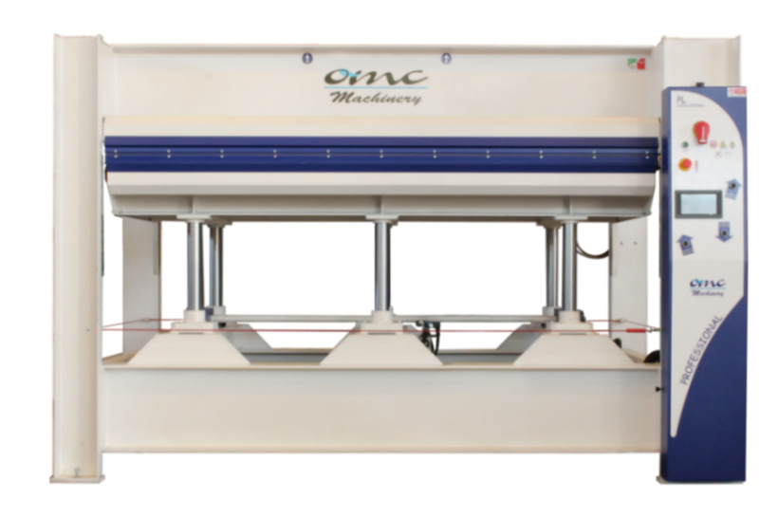

The pictures are for reference only.

Dear customer,

Thank you for enquiring with OMC Machinery.

OMC Machinery is an artisan family run business that since 1983 has designed, manufactured and installed top quality and highly reliable pressing machines.

We always provide our customers with technical assistance throughout the entire life cycle of the machinery, from the designing process to the after sales technical support, to ensure the maximum efficiency.

**HOT PRESS MODEL PL 90s 2500x1300 mm PS VBO**

|  |  |
| --- | --- |
| TECHNICAL CHARACTERISTICS | |
| Platens dimensions | 2500x1300 mm |
| Stroke | 400 mm |
| Type of stroke | Upstroke design (from bottom to top) |
| Type of platen | Assembled platens with coil and aluminum covering |
| Total thrust | 90 ton on 80% of the surface |
| Pressing Cylinders | N° 6 cylinders ø70 mm |
| Specific Pressure | 2.46 kg/cm2 on 100% of the surface  3.07 kg/cm2 on 80% of the surface |
| Loading and Unloading Side | 2500 mm side |
| Type of Heating system | Electric **Oil** Boiler maximum oil temperature 120°C |
| Heating system specifications | Electric boiler 18 kW |
| Opening | Automatic by timer |
| Control Board | Standard |
| Power supply | 400V, 50Hz, 3ph |
| Security device | Safety rope around the press  Red emergency Button  Two Hand control |
| Normative | CE norms |

**Press Structure**

The press structure is made of S275JR beams assembled and welded together.

The structure of both the fixed and movable platen is made of fe 430 beams assembled and welded together.

The press is equipped with rack and pinion guide system to ensure a perfectly parallel movement during the closing/opening of the platens.

**Assembled platens with coil and aluminium covering**

|  |  |
| --- | --- |
| Maximum oil Temperature **120°C**  Maximum specific working thrust **3-5 kg/cm²**  Maximum thrust of heating Fluid: **2 bar**  Our assembled platens with coil + aluminum covering are completely built in our metal workshop. Each coil, before being installed in the platen, is submitted to a strict leak test. | C:\Users\Marilena\Desktop\guida quotazioni\coilass.png |
| A **3 mm** calibrated sheet is placed on top of the coil.  The platens are covered with aluminum sheet, that gives the platens an excellent surface finish and optimal heat propagation.  **Hydraulic system**   * the hydraulic system consists of a double stage unit with submerged pump to reduce the noise and lubricate the rotating parts. * quick closing/opening pump (high delivery- low pressure **35 L/min**), pressing pump (low delivery-high pressure **1.6 L/min**). * **2 hp** electric engine * the hydraulic unit is equipped with the following control/safety valves, installed on the tank:   - maximum pressure valve: prevents to have too high pressure in the hydraulic  system in case of electric or electronic control fault  - pressure holding valve (retaining valve)  - low releasing pressure valve (pre-releasing valve). It avoids dangerous ram hits inside  the system  - oil release control magnet | |

|  |  |
| --- | --- |
| **Control panel and Electrical system**  The pressing parameters can be managed from the control board that is equipped with the following switches/ gauges:  - temperature gauge to control platens temperature  - Pressure regulating gauges and automatic pressure recovery system  - general on/off switch  - two hand safety switches to close the press  - Timer for automatic opening with its own switch activates the automatic  or manual opening of the platens after the work cycle.  - off/on switch for heating resistance that switches the boiler off when the  set temperature is reached to restore the temperature, if there is any  temperature decrease, in order to save power consumption.  - heating pump on/off switch |  |

**Safety systems**

- Timed bimanual control for press closing

- Safety rope on the four sides of the press

- Platen locking device for maintenance

- Protection carter for the pinion/rack units

- Safety stickers and warnings

- Use and maintenance manual

- the press is compliant with CE standards

**HOT PRESS MODEL PL 90s 2500x1300 mm PS VBO (Oil boiler)**