

2018 Cehisa Compact PCS High Specification Edgebander

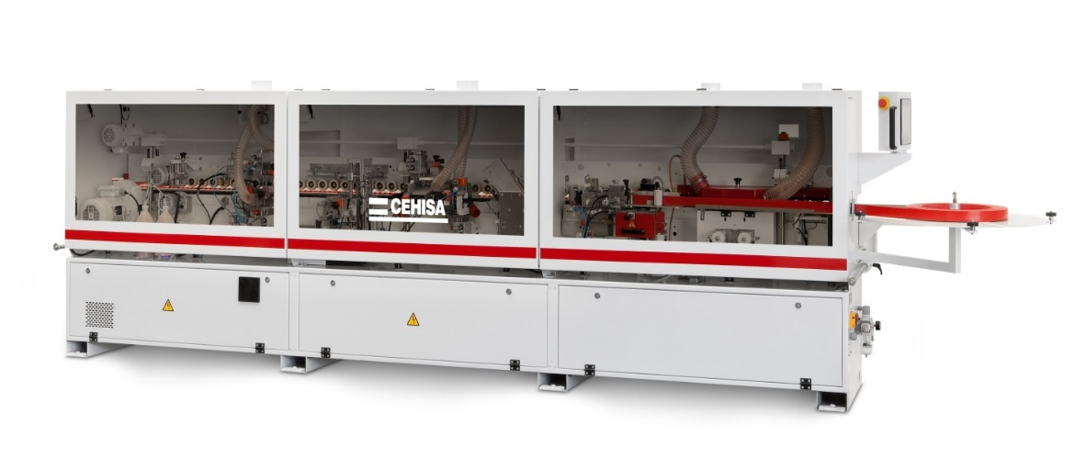

**CEHISA COMPACT PCS EDGEBANDER WITH PREMILLING/ CORNER ROUNDING**

|  |  |  |  |  |  |
| --- | --- | --- | --- | --- | --- |
| **TECHNICAL FEATURES** |  |  |  | | **COMPACT PCS** |
| **Edgebanding Material** | | | | | |
| Melamine/PVC/ABS/PP/Veneer, mm | 0,4 – 3 | | | | |
| Solid wood strips, mm | Up to 5 (manual feed one by one) | | | | |
| **Panel** | | | | | |
| Thickness min-max, mm | 8 – 60 | | | | |
| Length min-max, mm | 120 – unlimited | | | | |
| Width min-max | 75 – unlimited / 60 – unlimited (optional) | | | | |
| **Machine Characteristics** | | | | | |
| Working speed, m/min | 10 | 10 / 8 | | 10 | 10 / 8 |
| Corner rounding unit capacity, mm | - | 10 – 60 | - | | 10 – 60 |
| Pre-milling cutters height, mm | - | - | 65 | | |
| Working pressure, kg/cm2 | 6 - 7 | | | | |
| Total electrical output, kW | 9,3 | 10,3 | 11,5 | | 12,5 |
| Electrical connection | 3 x 380V/50Hz | | | | |
| Dimensions, mm (LxWxH) |  |  |  | | 3564x630x1370 |
| Net weight, Kg. |  |  |  | | 1186 |

**MACHINE DESCRIPTION**

|  |  |
| --- | --- |
| **Feeding Unit** | |
| E:\catFLEXY\grupi\roll magazine.jpg | ◻ Roll tray for edge band in rolls. |
| ◻ Timer controlled automatic feed allowing the precise adjustment of the in-feed surplus and minimizing the waste of edging material. |
| ◻ Possibility for manual feed of solid wood strips of up to 5 mm thickness. |
| ◻ Pneumatic cut-off guillotine (fit for PVC/ABS edges of up to 3 mm thickness). |
| **Pre-Milling Unit PF-2** | |
|  | ◻ 2 HF motors – the first of 1,1 kW, rotating CW and the second 0,75 kW rotating CCW, with pneumatic pressure control on both motors, providing optimum finish. |
| ◻ Milling heads with welded dia. |
| * Standard tooling spec: Ø60 Ø20 H30 Z6   tooling spec Ø60 Ø20 H65 Z6. |
| **Glue Application Unit M2-NS** | |
| E:\catFLEXY\grupi\M2NS cropped.jpg | ◻ New design with improved thermodynamics, granting a shorter heating with less power consumption (2,5 kW). Full TEFLON® coating of the whole assembly. |
| ◻ Injection of the melted glue at the upper and the lower points of the application roller where heating elements are built in to maintain optimum working temperature. |
| ◻ Automatic control by electronic thermostat preventing the scorching of the glue when the machine is idle. 1,5 kg capacity glue tank. |
| ◻ DUOMELT upgrade pack, allowing the use of the unit both with EVA and PUR adhesives. The option pack includes a simple and efficient draining system for the residual glue in the glue pot and the necessary software to support this feature. |
| **Pressure Rollers** | |
|  | ◻ 3 rollers exerting pressure on the edge band mechanically in order to achieve its adhesion onto the panel edge. The first roller is driven and the second and the third ones are of smaller diameter and idle. |
| ◻ SIKO numerical counter for unit adjustment to 3 mm edge / 5 mm strips. |
| ◻ **OPTIONAL:** Automatic positioning at 2 pre-set positions (Exp. 0,4 / 2,0 mm). |
| **End Trimming (snipping) V-3** | |
|  | ◻ Single support / single carriage / single through shaft HF motor (0,27 kW/12000 rpm) / two TCT saws, performing the front and the rear trim cut cycles. |
| ◻ Soft and precise movement of the carriage slip on precision prismatic guides. |
| ◻ Tooling: 2 x TCT sawblades Ø100x32x3 Z30. |
| **Top & Bottom Trimming Station JC-3** | |
| E:\catFLEXY\grupi\JC-2 top&bottom trim cropped.jpg | ◻ 2 separate units, powered by for the machining of the excess of the edge band along the upper and the lower edges of the panel. |
| ◻ 2 HF motors of 0,55 kW / 12000 rpm.. |
| ◻ Roller type tracers for work with high gloss and 3D effect panels and edges. |
| ◻ Tooling: milling cutters with TC changeable blades set Ø65x20x22 Z4 R2.  ◻ Automatic positioning at 2 pre-set positions (0,4 / 2 mm). |
| **Corner Rounding CR-2** | |
|  | ◻ Designed to round the 4 corners of the panel edged with 2 mm PVC/ABS band in order to achieve its complete finishing up to 60 mm. |
| ◻ Single carriage / single HF motor 0,27 kW / 12000 rpm, equipped with a tracer with 3D adjustment, performing the front and the rear panel rounding. |
| ◻ Not recommended for machining of deeper soft-formed or post-formed profiles. |
| ◻ Tooling: milling cutter with TC changeable blades. Ø73 x 20 x 20 Z4 R2. |

|  |  |
| --- | --- |
| **Radius Scraper RB-3 -** | |
|  | ◻ Designed to give the finishing touch of the radius of the PVC/BC edging after T&B trimming. |
| ◻ Roller type horizontal and vertical tracers with SIKO digital counters for precise and easy adjustment and cleaning by air blow nozzles. Extraction system with PVC/ABS waste collector. |
| ◻ Blade holders for fast and easy change. |
| ◻ Manual positioning of the station ON/OFF position. |
| ◻ Automatic positioning at 2 pre-set positions (ON / OFF). |
| **Glue Scraper RR-8 -** | |
| \\cehisa-server\publico_FOTOS Y VIDEOS\FLEXY\Nuevo catálogo Flexy\15100609.jpg | ◻ Designed to remove residues of glue along the glue line on the top & bottom faces of the panel. |
| ◻ Two blade holders with independently adjustable vertical copying devices. Blow nozzles for tracer cleaning. |
| ◻ Manual positioning of the station in ON/OFF position. |
| ◻ Automatic positioning at 2 pre-set positions (ON/OFF). |

|  |  |
| --- | --- |
| **Buffing Unit PC-3 -** | |
| \\cehisa-server\publico_FOTOS Y VIDEOS\FLEXY\Nuevo catálogo Flexy\15103004.jpg | ◻ Designed to restore the PVC/ABS edge color and polis hit after the trimming and scraping operations. |
| ◻ 2 independent units with tilting motors (2 x 0,05 kW / 15000 rpm) and hard cotton disks (Ø100 mm). |

Cont

|  |  |
| --- | --- |
| **Control Panel 7”** | |
|  | ◻ 7” TFT color touch LCD. |
| ◻ User friendly control with direct connection to the PLC, providing quick Access and monitoring of all machine functions (start/stop, program editing, parameters check & editing, alarms visualization, PLC I/O diagnostics) in real time.. |
| ◻ Multi-language support and 128 Mb of memory for storage of screen data and job programs. |

**HIGH SPECIFICATION CONFIGURATION**

♦ HF motors controlled by independent electronic inverters.

♦ Electrical part, meeting the respective CE norms.

♦ Control panel with touchscreen display and integrated PLC.

♦ Pressure beam with synchronized up/down movement.

♦ Extension roller support for big size workpieces.

♦ Dust extraction hoods on all work stations.

♦ Air blow nozzles for tracers cleaning.

♦ Cabin, housing all working units.

**Specification Includes**

**2 Position setting from control panel for thick and thin tapes £ Included**

**Pneumatic ON/OFF Edge scrapers £ Included**

**Pneumatic ON/OFF Glue scrapers £ Included**

**Motorised Top Beam for Panel Height £ Included**

**Included 65mm Diamond Pre-Milling Tools**

**Non stick spray agent/Unit £ Included**

**Clean Spray Application Unit £ Included**

**Nesting Tracer wheels for hinge holes on panel £ Included**

**LED Cabin Lights Included**

**Machine Length 3435mm**